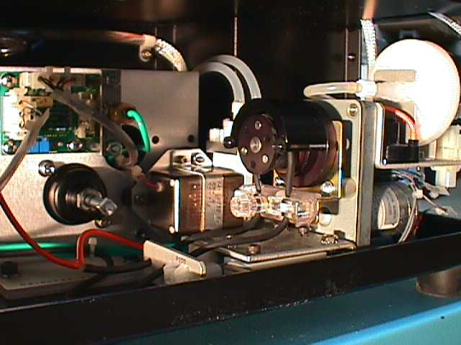
Differential pressure regulator
C-clamp
Step 2. Remove center retainer nut to release the lower tubing clamp.
SIP to DCM
DCM to waste
Air pump
Step 3. Loosen inboard side of clamp using the thumb-screw or a 3/32 allen wrench.
Step 1. Remove black DCM tubing from these connections. Inspect connectors for degeneration.
Step 4. Remove outboard screw in order to pivot the C – clamp on inboard screw.
Step 5. Remove and replace DCM tubing.
Step 6. Install lower tubing clamp. Remove slack from tubing. Tighten lower clamp retainer nut to secure tubing from slipping.
Step 7. Return the C-clamp and screw. Press down firmly on the top while tightening screws.
Step 8. Test for leakage by changing the sample repeatedly in RUN. Look for drips at the SIP & connections. Observe that sample does not disappear rapidly. Aspirate 2ml of DI water by moving the stage to the side to check DCM pumping action. Re-check tubing slack (Step 6).

